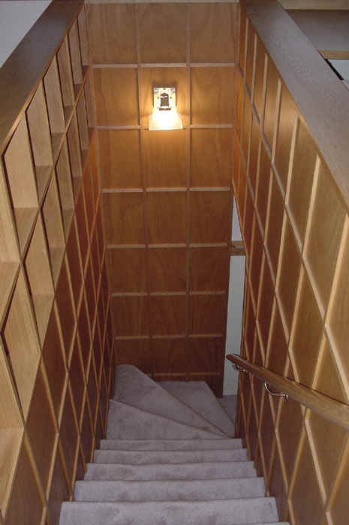
The Online Bargain Basement

by Kathi Kearney, kkearney@midcoast.com
and Carolyn K., webmaster@hoagiesgifted.org

Welcome to the basement, full of Free online resources for gifted education!

How to choose?
Review the course thoroughly, reviewing all units and materials
Make sure the course suits the student’s academic needs, learning style, and is easy to use
Do a trial run…

How to use an online course?
Make sure there’s someone available for support: technical and content support
You don’t have to know the material, but you do need to guide the student
Keep the student motivated
Keep records – log daily progress
Engage the student in discussion
Discussion can be with teacher, mentor or older student, classroom volunteer, etc.
If you are completely dependent on the online course as curriculum, make a copy on the computer’s hard drive
**WebWhacker

Select a course…

High School (and early college) courses
www.hoagiesgifted.org/online_hs.htm

Score Cyberguides – online Literature units
www.sdcoe.k12.ca.us/score/cyberguide.html

Monterey Institute AP courses – Calculus, Physics, U.S. Government and U.S. History
www.archive.org/details/ap_courses

ALEKS – K-12 plus higher education mathematics
www.aleks.com
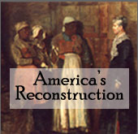
MIT Open Courseware
http://ocw.mit.edu/OcwWeb/Physics/8-01Physics-IFall1999/CourseHome

Digital History
www.digitalhistory.uh.edu/

BYU Independent Study Exercise Sciences
http://ce.byu.edu/courses/pe/999052076004/public/start.htm

WebTeacher
www.webteacher.org/

BBC Languages
www.bbc.co.uk/languages/

U. of Texas -- Austin College French class
www.laits.utexas.edu/fi/


Annenberg Media Teacher Resources
www.learner.org/resources/browse.html

Also visit…

Free Online Text Materials
www.hoagiesgifted.org/online_texts.htm

Free Materials for Gifted Classrooms
www.hoagiesgifted.org/materials.htm

Internet Investigations – Free curriculum units and libraries
www.hoagiesgifted.org/investigations.htm

**To copy an entire websites to your hard drive, use a tool like WebWhacker
http://www.bluesquirrel.com/products/webwhacker/


Hoagies’ Gifted Education Page
www.hoagiesgifted.org

©2006 Carolyn K. and Kathi Kearney

